# 4.6 Rotation Matrices in 3-Dimensions

## The Three Basic Rotations

A basic rotation of a vector in 3-dimensions is a rotation around one of the coordinate axes. We can rotate a vector counterclockwise through an angle $θ$ around the $x$–axis, the $y$–axis, or the $z$–axis.

To get a counterclockwise view, imagine looking at an axis straight on toward the origin.

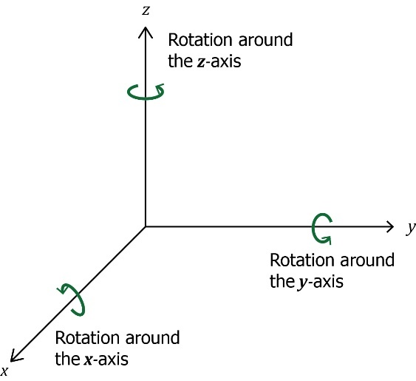

Our plan is to rotate the vector $\left[\begin{matrix}x \\ y \\ z\end{matrix}\right]$ counterclockwise around one of the axes through some angle $θ$ to the new position given by the vector $\left[{\begin{matrix}x \\ y' \\ z'\end{matrix}}^{'}\right]$. To do so, we will use one of three rotation matrices.

## The Rotation Matrices

The rotation matrices for $x$, $y$, and $z$ axes are, respectively,

$$\left[\begin{matrix}1 & 0 & 0 \\ 0 & cosθ & -sinθ \\ 0 & sinθ & cosθ\end{matrix}\right] \left[\begin{matrix}cosθ & 0 & sinθ \\ 0 & 1 & 0 \\ -sinθ & 0 & cosθ\end{matrix}\right] \left[\begin{matrix}cosθ & -sinθ & 0 \\ sinθ & cosθ & 0 \\ 0 & 0 & 1\end{matrix}\right]$$

## The Rotation Process

To rotate the vector $\left[\begin{matrix}x \\ y \\ z\end{matrix}\right]$ counterclockwise through an angle $θ$ around the $x$–axis to a new position $\left[{\begin{matrix}x \\ y' \\ z'\end{matrix}}^{'}\right],$ perform the matrix multiplication,

The –axis

To rotate the vector $\left[\begin{matrix}x \\ y \\ z\end{matrix}\right]$ counterclockwise through an angle $θ$ around the $y$–axis to a new position $\left[{\begin{matrix}x \\ y' \\ z'\end{matrix}}^{'}\right],$ perform the matrix multiplication,

The –axis

To rotate the vector $\left[\begin{matrix}x \\ y \\ z\end{matrix}\right]$ counterclockwise through an angle $θ$ around the $z$–axis to a new position $\left[{\begin{matrix}x \\ y' \\ z'\end{matrix}}^{'}\right],$ perform the matrix multiplication,

The $z$–axis

$$\left[{\begin{matrix}x \\ y' \\ z'\end{matrix}}^{'}\right]=\left[\begin{matrix}cosθ & -sinθ & 0 \\ sinθ & cosθ & 0 \\ 0 & 0 & 1\end{matrix}\right]∙\left[\begin{matrix}x \\ y \\ z\end{matrix}\right]$$

Find the vector $\left[{\begin{matrix}x \\ y' \\ z'\end{matrix}}^{'}\right]$ that results when the vector $\left[\begin{matrix}x \\ y \\ z\end{matrix}\right]=\left[\begin{matrix}1 \\ 2 \\ 3\end{matrix}\right]$ is rotated 90° counterclockwise around $x$–axis.

Example (1)

Using the rotation formula $\left[{\begin{matrix}x \\ y' \\ z'\end{matrix}}^{'}\right]=\left[\begin{matrix}1 & 0 & 0 \\ 0 & cosθ & -sinθ \\ 0 & sinθ & cosθ\end{matrix}\right]∙\left[\begin{matrix}x \\ y \\ z\end{matrix}\right]$ with $\left[\begin{matrix}x \\ y \\ z\end{matrix}\right]=\left[\begin{matrix}1 \\ 2 \\ 3\end{matrix}\right]$ and $θ=90°,$ we get

$\left[{\begin{matrix}x \\ y' \\ z'\end{matrix}}^{'}\right]=\left[\begin{matrix}1 & 0 & 0 \\ 0 & cosθ & -sinθ \\ 0 & sinθ & cosθ\end{matrix}\right]∙\left[\begin{matrix}x \\ y \\ z\end{matrix}\right] =\left[\begin{matrix}1 & 0 & 0 \\ 0 & cos90° & -sin90° \\ 0 & sin90° & cos90°\end{matrix}\right]∙\left[\begin{matrix}1 \\ 2 \\ 3\end{matrix}\right]$

$\left[{\begin{matrix}x \\ y' \\ z'\end{matrix}}^{'}\right]=\left[\begin{matrix}1 & 0 & 0 \\ 0 & 0 & -1 \\ 0 & 1 & 0\end{matrix}\right]∙\left[\begin{matrix}1 \\ 2 \\ 3\end{matrix}\right]=\left[\begin{matrix}1∙1+0∙2+0∙3 \\ 0∙1+0∙2+(-1)∙3 \\ 0∙1+1∙2+0∙3\end{matrix}\right]$

$\left[{\begin{matrix}x \\ y' \\ z'\end{matrix}}^{'}\right]=\left[\begin{matrix}1 \\ -3 \\ 2\end{matrix}\right]$

When rotated counterclockwise 90° around the $x$–axis, the vector $\left[\begin{matrix}1 \\ 2 \\ 3\end{matrix}\right]$ becomes $\left[\begin{matrix}1 \\ -3 \\ 2\end{matrix}\right]$.

## Using Technology

We can use technology to help us find the rotation. WolframAlpha evaluates the trig functions for us.

Go to www.wolframalpha.com.

In Example 1, we rotated the vector $\left[\begin{matrix}1 \\ 2 \\ 3\end{matrix}\right]$ 90° around the $x$–axis to get $\left[\begin{matrix}1 \\ -3 \\ 2\end{matrix}\right].$

Example (2)

Now we will use WolframAlpha to rotate vector $\left[\begin{matrix}1 \\ 2 \\ 3\end{matrix}\right]$ 90° around the $y$–axis. We use the $y$–axis rotation matrix $\left[\begin{matrix}cosθ & 0 & sinθ \\ 0 & 1 & 0 \\ -sinθ & 0 & cosθ\end{matrix}\right]$.

To perform the rotation, enter Evaluate [ [cos(90),0,sin(90)], [0,1,0], [–sin(90),0,cos(90)] ] * [1,2,3] into the entry field.

Both entries and rows are separated by commas as W|A does not see spaces.

Wolframalpha tells you what it thinks you entered, then tells you its answer.

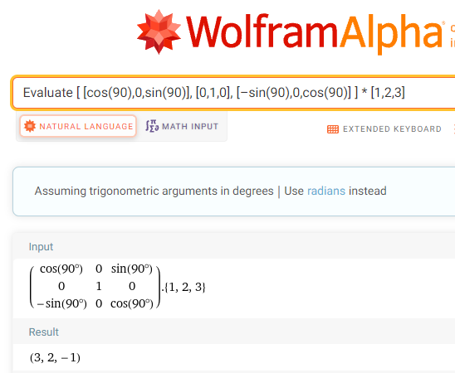

When rotated counterclockwise 90° around the $y$–axis, the vector $\left[\begin{matrix}1 \\ 2 \\ 3\end{matrix}\right]$ becomes $\left[\begin{matrix}3 \\ 2 \\ -1\end{matrix}\right]$.

Find the vector $\left[{\begin{matrix}x \\ y' \\ z'\end{matrix}}^{'}\right]$ that results when the vector $\left[\begin{matrix}x \\ y \\ z\end{matrix}\right]=\left[\begin{matrix}1 \\ 2 \\ 3\end{matrix}\right]$ is rotated 45° counterclockwise around the $z$–axis.

Example (3)

Since we are rotating the vector around the $z$–axis, we use the $z$–axis rotation

matrix $\left[\begin{matrix}cosθ & -sinθ & 0 \\ sinθ & cosθ & 0 \\ 0 & 0 & 1\end{matrix}\right]$.

Using WolframAlpha with $\left[\begin{matrix}x \\ y \\ z\end{matrix}\right]=\left[\begin{matrix}1 \\ 2 \\ 3\end{matrix}\right]$ and $θ=45°,$ we get

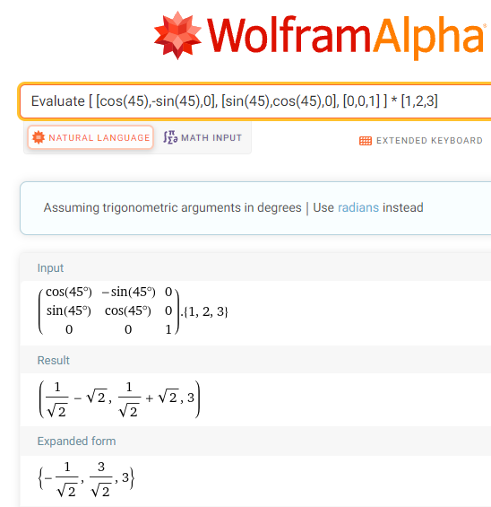

When rotated counterclockwise 45° around the $z$–axis, the vector $\left[\begin{matrix}1 \\ 2 \\ 3\end{matrix}\right]$ becomes $\left[\begin{matrix}-1/\sqrt{2} \\ 3/\sqrt{2} \\ 3\end{matrix}\right]$.

## EXAMPLES

Find the vector $\left[{\begin{matrix}x \\ y' \\ z'\end{matrix}}^{'}\right]$ that results when the given vector $\left[\begin{matrix}x \\ y \\ z\end{matrix}\right]$ is rotated the given angle $θ$ counterclockwise around the given axis.

1. $\left[\begin{matrix}x \\ y \\ z\end{matrix}\right] =\left[\begin{matrix}1 \\ 1 \\ 1\end{matrix}\right]$ through 90° around the $x$–axis. ANS: $\left[\begin{matrix}1 \\ -1 \\ 1\end{matrix}\right]$

1. $\left[\begin{matrix}x \\ y \\ z\end{matrix}\right] =\left[\begin{matrix}1 \\ 0 \\ 1\end{matrix}\right]$ through 45° around the $z$–axis. ANS: $\left[\begin{matrix}\sqrt{2} \\ 0 \\ 1\end{matrix}\right]$

1. $\left[\begin{matrix}x \\ y \\ z\end{matrix}\right] =\left[\begin{matrix}3 \\ 4 \\ 5\end{matrix}\right]$ through 30° around the $y$–axis. ANS: $\left[\begin{matrix}3 \\ -5 \\ 4\end{matrix}\right]$

## Note to Instructor

Consider noting that if we are familiar with the 2-D rotation matrices of Chapter 4.4, then the 3-D rotation matrix for rotating a vector around the $x$–axis may not be a surprise.

* For 2-D, the rotation matrix is $\left[\begin{matrix}cosθ & -sinθ \\ sinθ & cosθ\end{matrix}\right]$
* For 3-D, the rotation matrix around the $x$–axis is

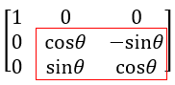

Look closely at the last two rows and two columns.

The 2-D rotation matrix shows up in the 3-D rotation matrix. $\left[\begin{matrix}1 & 0 & 0 \\ 0 & cosθ & -sinθ \\ 0 & sinθ & cosθ\end{matrix}\right]$

The fist column in the 3-D rotation matrix is $\left[\begin{matrix}1 \\ 0 \\ 0\end{matrix}\right]$

These are the numbers that when the multiplication is performed, keep the $x$-component the same.

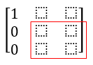

What happens in the $y$ and $z$ components is just a rotation in the plane. The $y$-axis rotates counterclockwise toward the $z$-axis, so in the lower right part of the 3x3 matrix, we will have the standard rotation matrix that we saw for the plane in Chapter 4.4.

Consider demonstrating these examples.

Find the vector $\left[{\begin{matrix}x \\ y' \\ z'\end{matrix}}^{'}\right]$ that results when the given vector $\left[\begin{matrix}x \\ y \\ z\end{matrix}\right]$ is rotated the given angle $θ$ counterclockwise around the given axis.

1. $\left[\begin{matrix}x \\ y \\ z\end{matrix}\right] =\left[\begin{matrix}5 \\ 4 \\ 3\end{matrix}\right]$ through 90° around the $x$–axis.

Using the rotation formula $\left[{\begin{matrix}x \\ y' \\ z'\end{matrix}}^{'}\right]=\left[\begin{matrix}1 & 0 & 0 \\ 0 & cosθ & -sinθ \\ 0 & sinθ & cosθ\end{matrix}\right]∙\left[\begin{matrix}x \\ y \\ z\end{matrix}\right]$ with $\left[\begin{matrix}x \\ y \\ z\end{matrix}\right]=\left[\begin{matrix}5 \\ 4 \\ 3\end{matrix}\right]$ and $θ=90°,$ we get

$\left[{\begin{matrix}x \\ y' \\ z'\end{matrix}}^{'}\right]=\left[\begin{matrix}1 & 0 & 0 \\ 0 & cosθ & -sinθ \\ 0 & sinθ & cosθ\end{matrix}\right]∙\left[\begin{matrix}x \\ y \\ z\end{matrix}\right] =\left[\begin{matrix}1 & 0 & 0 \\ 0 & cos90° & -sin90° \\ 0 & sin90° & cos90°\end{matrix}\right]∙\left[\begin{matrix}5 \\ 4 \\ 3\end{matrix}\right]$

$\left[{\begin{matrix}x \\ y' \\ z'\end{matrix}}^{'}\right]=\left[\begin{matrix}1 & 0 & 0 \\ 0 & 0 & -1 \\ 0 & 1 & 0\end{matrix}\right]∙\left[\begin{matrix}1 \\ 2 \\ 3\end{matrix}\right]=\left[\begin{matrix}1∙5+0∙4+0∙3 \\ 0∙5+0∙4+(-1)∙3 \\ 0∙5+1∙4+0∙3\end{matrix}\right]$

$\left[{\begin{matrix}x \\ y' \\ z'\end{matrix}}^{'}\right]=\left[\begin{matrix}5 \\ -3 \\ 4\end{matrix}\right]$

When rotated counterclockwise 90° around the $x$–axis, the vector $\left[\begin{matrix}5 \\ 4 \\ 3\end{matrix}\right]$ becomes $\left[\begin{matrix}5 \\ -3 \\ 4\end{matrix}\right]$.

1. $\left[\begin{matrix}x \\ y \\ z\end{matrix}\right] =\left[\begin{matrix}0 \\ 0 \\ 1\end{matrix}\right]$ through 60° around the $y$–axis.

Using the rotation formula $\left[{\begin{matrix}x \\ y' \\ z'\end{matrix}}^{'}\right]=\left[\begin{matrix}cosθ & 0 & sinθ \\ 0 & 1 & 0 \\ -sinθ & 0 & cosθ\end{matrix}\right]∙\left[\begin{matrix}x \\ y \\ z\end{matrix}\right]$ with $\left[\begin{matrix}x \\ y \\ z\end{matrix}\right]=\left[\begin{matrix}0 \\ 0 \\ 1\end{matrix}\right]$, $θ=60°,$ and WolframAlpha we get

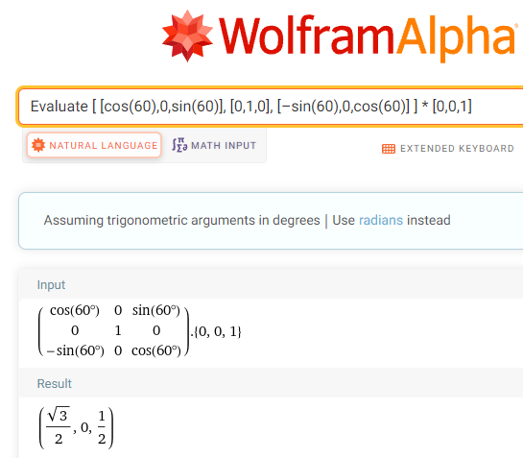

When rotated counterclockwise 60° around the $y$–axis, the vector $\left[\begin{matrix}1 \\ 2 \\ 3\end{matrix}\right]$ becomes .

[4-6_rotation_matrices_in_3_dimensions.docx](https://oer4cte.org/math4gamedevelopers/teacher/4-6_rotation_matrices_in_3_dimensions.docx), attributed to Denny Burzynski (author) and Downey Unified School District (publisher) is licensed under CC BY-NC 4.0. To view a copy of this license, visit https://creativecommons.org/licenses/by-nc/4.0